**Grade 10 – Science Chapter 13 – Our Environment**

**Multiple Choice Questions:**

1. Which of the following is a bio-degradable waste?

a) Plastic bags

b) Glass bottles

c) Vegetable peels

d) Aluminum cans

Answer: c) Vegetable peels

Difficulty level: Easy

Bloom's Taxonomy: Remembering

Topic: Our Environment

Score: 1

2.Which of the following is a non-biodegradable waste?

a)Glass bottles

b) Food waste

c) Paper

d) Vegetable peels

Answer: a)Glass bottles

Difficulty level: Easy

Bloom's Taxonomy: Remembering

Topic: Our Environment

Score: 1

3. What is the process of converting waste into compost called?

a) Recycling

b) Composting

c) Incineration

d) Land filling

Answer: b) Composting

Difficulty level: Easy

Bloom's Taxonomy: Remembering

Topic: Our Environment

Score: 1

4. Which of the following is a renewable resource?

a) Solar energy

b) Petroleum

c) Coal

d) Natural gas

Answer: a) Solar energy

Difficulty level: Easy

Bloom's Taxonomy: Remembering

Topic: Our Environment

Score: 1

5. Which of the following is a non-renewable resource?

a) Wind energy

b) Solar energy

c) Hydroelectric power

d) Fossil fuels

Answer: d) Fossil fuels

Difficulty level: Easy

Bloom's Taxonomy: Remembering

Topic: Our Environment

Score: 1

6.Which of the following is a greenhouse gas?

a) Oxygen

b) Nitrogen

c) Helium

d) Carbon dioxide

Answer: d) Carbon dioxide

Difficulty level: Easy

Bloom's Taxonomy: Remembering

Topic: Our Environment

Score: 1

7. Which of the following measures can help conserve biodiversity?

a) Hunting endangered species for food

b) Deforestation for agricultural expansion

c) Establishing protected areas and wildlife reserves

d) Introducing invasive species to new ecosystems

Answer: c) Establishing protected areas and wildlife reserves

Difficulty Level: Medium

Bloom's Taxonomy: Applying

Topic: Our Environment

Score: 1

8.Which of the following is a method of reducing air pollution?

a) Burning fossil fuels

b) Using public transportation

c) Deforestation

d) Using plastic bags

Answer: b) Using public transportation

Difficulty level: Easy

Bloom's Taxonomy: Remembering

Topic: Our Environment

Score: 1

9.Which of the following is a method of conserving water?

a) Leaving the tap running while brushing teeth

b) Taking long showers

c) Fixing leaky faucets

d) Watering the lawn every day

Answer: c) Fixing leaky faucets

Difficulty level: Easy

Bloom's Taxonomy: Remembering

Topic: Our Environment

Score: 1

10. What is not caused by non-biodegradable waste?

a) Soil pollution

b) Water pollution

c) Air pollution

d) Noise Pollution

Answer: d) Noise Pollution

Difficulty: Easy

Bloom's Taxonomy: Understanding

Topic: Our Environment

Score: 1

11. Can the organisms of any trophic level be removed without causing damage to the ecosystem?

a) Yes, they can be removed without any impact

b) No, their removal will disrupt the ecosystem

c) Only organisms of the highest trophic level can be removed without impact

d) Only organisms of the lowest trophic level can be removed without impact

Answer: b) No, their removal will disrupt the ecosystem

Difficulty: Easy

Bloom's Taxonomy: Understanding

Topic: Our Environment

Score: 1

12. What is the level of biological magnification at different levels of the ecosystem?

a) It is same at all levels

b) It decreases with each level

c) It increases with each level

d) It depends on the type of ecosystem

Answer: c) It increases with each level

Difficulty: Easy

Bloom's Taxonomy: Understanding

Topic: Our Environment

Score: 1

13. If all the waste we generate is biodegradable, will this have no impact on the environment?

a) There will be no impact on the environment

b) Biodegradable waste also contributes to pollution

c) Biodegradable waste has no impact on the environment

d) Only non-biodegradable waste has an impact

Answer: b) Biodegradable waste also contributes to pollution

Difficulty: Easy

Bloom's Taxonomy: Understanding

14. Why is damage to the ozone layer a cause for concern?

a) It leads to climate change

b) It causes depletion of the ozone layer

c) It increases the risk of skin cancer

d) It causes earthquakes and land slides

Answer: c) It increases the risk of skin cancer

Difficulty: Easy

Bloom's Taxonomy: Understanding

Topic: Our Environment

Score: 1

15. What steps are being taken to limit the damage to the ozone layer?

a) Increased use of CFCs

b) International regulations and practices

c) Using machines or sources which produce gases containing Ozone -depleting Substances (ODS)

d) No steps are being taken

Answer: b) International regulations and practices

Difficulty: Easy

Bloom's Taxonomy: Understanding

Topic: Our Environment

Score: 1

16. What are the two components of an ecosystem?

a) Biotic and abiotic

b) Biodegradable and non-biodegradable

c) Producer and consumer

d) Primary consumer and secondary consumer

Answer: a) Biotic and abiotic

Difficulty: Easy

Bloom's Taxonomy: Remembering

Topic: Our Environment

Score: 1

17. Which of the following constitutes a food-chain?

a) Grass, wheat and mango

b) Grass, goat and human

c) Goat, cow and elephant

d) Grass, fish and goat

Difficulty Level: Easy

Bloom's Taxonomy: Remembering

Topic: Our Environment

Score: 1

18. Which of the following materials will be broken down by bacteria or other saprophytes?

a) Plastics

b) Coal

c) Biodegradable waste

d) Metals

Answer: c) Biodegradable waste

Difficulty: Easy

Bloom's Taxonomy: Remembering

Topic: Our Environment

Score: 1

19. What is the primary purpose of recycling?

a) To reduce pollution

b) To conserve energy

c) To conserve natural resources

d) To generate revenue

Answer: c) To conserve natural resources

Difficulty Level: Easy

Bloom's Taxonomy: Understanding

Topic: Our Environment

Score: 1

20. Which of the following is an example of a renewable resource?

a) Natural gas

b) Coal

c) Solar energy

d) Nuclear energy

Answer: c) Solar energy

Difficulty Level: Medium

Bloom's Taxonomy: Analyzing

Topic: Our Environment

Score: 1

21. Which of the following is an example of a non-biodegradable pollutant?

a) Paper

b) Vegetable waste

c) Plastic

d) Leaves

Answer: c) Plastic

Difficulty Level: Easy

Bloom's Taxonomy: Remembering

Topic: Our Environment

Score: 1

22. Which of the following actions would contribute to reducing carbon footprint?

a) Driving a car instead of cycling

b) Using energy-efficient appliances

c) Leaving lights and electronic devices on when not in use

d) Using single-use plastic bags

Answer: b) Using energy-efficient appliances

Difficulty Level: Medium

Bloom's Taxonomy: Applying

Topic: Our Environment

Score: 1

23. What is the term for the process in which the concentration of harmful substances increases as it moves up the food chain?

a) Biological magnification

b) Photosynthesis

c) Biodegradation

d) Ozone depletion

Answer: a) Biological magnification

Difficulty: Easy

Bloom's Taxonomy: Understanding

Topic: Our Environment

Score: 1

24.What is the main cause of damage to the ozone layer?

a) Deforestation

b) Climate change

c) Release of CFCs

d) Industrial pollution

Answer: c) Release of CFCs

Difficulty: Easy

Bloom's Taxonomy: Understanding

Topic: Our Environment

Score: 1

**Very Short Answer Questions:**

25. What is the difference between biodegradable and non-biodegradable waste?

Answer: Biodegradable waste can be broken down by natural processes, while non-biodegradable waste cannot.

Difficulty level: Easy

Bloom's Taxonomy: Understanding

Topic: Our Environment

Score: 2

26. How do our activities affect the environment?

Answer: Our activities can have both positive and negative impacts on the environment, depending on the nature of the activity and how it is carried out.

Difficulty level: Easy

Bloom's Taxonomy: Understanding

Topic: Our Environment

Score: 2

27. What is the greenhouse effect?

Answer: The greenhouse effect is the process by which certain gases in the Earth's atmosphere trap heat from the sun, leading to an increase in the Earth's temperature.

Difficulty level: Easy

Bloom's Taxonomy: Remembering

Topic: Our Environment

Score: 2

28. What is global warming?

Answer: Global warming is the long-term increase in the Earth's average surface temperature due to human activities, such as burning fossil fuels and deforestation.

Difficulty level: Easy

Bloom's Taxonomy: Remembering

Topic: Our Environment

Score: 2

29. What is the ozone layer?

Answer: The ozone layer is a layer of ozone gas in the Earth's stratosphere that absorbs most of the sun's ultraviolet radiation.

Difficulty level: Easy

Bloom's Taxonomy: Remembering

Topic: Our Environment

Score: 2

30. What is biological magnification?

Answer: Biological magnification is the process by which certain substances, such as pesticides and heavy metals, become more concentrated in the tissues of organisms at higher trophic levels in a food chain.

Difficulty level: Easy

Bloom's Taxonomy: Remembering

Topic: Our Environment

Score: 2

31. What is the concern regarding the depletion of the ozone layer?

Answer: Depletion of the ozone layer allows more ultraviolet radiation from the Sun to reach the Earth's surface, which can harm living organisms and contribute to climate change.

Difficulty Level: Easy

Bloom's Taxonomy: Remembering

Topic: Our Environment

Score: 2

**Short Answer Questions:**

32. Define an ecosystem and list its components.

Answer: An ecosystem is a community of organisms interacting with each other and their physical environment. Its components include biotic (living) factors such as plants, animals, and microorganisms, as well as abiotic (non-living) factors like sunlight, temperature, water, soil, etc.

Difficulty: Easy

Bloom's Taxonomy: Remembering

Topic: Our Environment

Score: 3

33. How does the presence of decomposers contribute to an ecosystem?

Answer: Decomposers break down dead organic matter and recycle nutrients back into the ecosystem, promoting nutrient cycling and maintaining the balance of nutrients in the environment. Difficulty: Easy

Bloom's Taxonomy: Understanding

Topic: Our Environment

Score: 3

34. Explain how our activities impact the air quality in an ecosystem.

Answer: Human activities such as industrial emissions, vehicle exhaust, and burning of fossil fuels release pollutants into the air, leading to air pollution and degradation of air quality in the ecosystem.

Difficulty: Easy

Bloom's Taxonomy: Understanding

Topic: Our Environment

Score: 3

35. Describe the relationship between deforestation and climate change.

Answer: Deforestation contributes to climate change by reducing the number of trees that absorb carbon dioxide through photosynthesis. This leads to an increase in greenhouse gases in the atmosphere, trapping heat and causing global warming.

Difficulty: Easy

Bloom's Taxonomy: Understanding

Topic: Our Environment

Score: 3

36. How can the concept of sustainable development help mitigate environmental problems? Answer: Sustainable development promotes the efficient use of resources, conservation of biodiversity, and the integration of environmental, social, and economic factors. It aims to meet the needs of the present generation without compromising the ability of future generations to meet their own needs.

Difficulty: Easy

Bloom's Taxonomy: Understanding

Topic: Our Environment

Score: 3

37. Discuss the role of environmental education in creating awareness about conservation.

Answer: Environmental education plays a crucial role in creating awareness about conservation by providing knowledge, promoting a sense of responsibility, and inspiring individuals to take positive actions to protect and preserve the environment.

Difficulty: Easy

Bloom's Taxonomy: Understanding

Topic: Our Environment

Score: 3

38. Explain the concept of sustainable agriculture and its benefits.

Answer: Sustainable agriculture is a farming approach that focuses on long-term productivity while minimizing the negative environmental impacts. It promotes the use of organic practices, crop rotation, water conservation, and biodiversity conservation, leading to improved soil health, reduced pollution, and sustainable food production.

Difficulty: Easy

Bloom's Taxonomy: Understanding

Topic: Our Environment

Score: 3

**Long Answer Questions:**

39. Discuss the importance of biodiversity in maintaining ecosystem balance and functioning. Answer: Biodiversity refers to the variety of life forms in an ecosystem, including genetic, species, and ecosystem diversity. It plays a crucial role in maintaining ecosystem balance and functioning. Biodiversity ensures the availability of various ecosystem services such as pollination, nutrient cycling, and pest control. It enhances the resilience of ecosystems and helps them adapt to environmental changes. Loss of biodiversity can disrupt ecosystem stability and result in cascading effects on the entire ecosystem.

Difficulty: Easy

Bloom's Taxonomy: Understanding

Topic: Our Environment

Score: 5

40. Explain the concept of the food chain and elaborate on its importance in an ecosystem.

Answer: A food chain is a linear sequence that shows the transfer of energy and nutrients from one organism to another in an ecosystem. It begins with a producer (plants) that converts sunlight into chemical energy through photosynthesis, followed by a series of consumers (herbivores, carnivores, and omnivores) that feed on each other. Decomposers break down dead organisms and recycle nutrients back into the ecosystem. The food chain illustrates the flow of energy and matter through different trophic levels, highlighting the interdependence of organisms in an ecosystem.

Difficulty: Easy

Bloom's Taxonomy: Understanding

Topic: Our Environment

Score: 5

41. Explain the concept of an ecosystem and discuss the interdependence of its components. Answer: An ecosystem is a community of organisms interacting with each other and their physical environment. It consists of biotic (living) components such as plants, animals, and microorganisms, as well as abiotic (non-living) components like air, water, soil, and sunlight. The components of an ecosystem are interdependent, meaning they rely on each other for survival and well-being. For example, plants produce oxygen and provide food for animals, while animals help in pollination and seed dispersal for plants. The interdependence ensures the balance and functioning of the ecosystem.

Difficulty: Easy

Bloom's Taxonomy: Understanding

Topic: Our Environment

Score: 5

42.Explain the concept of bioaccumulation and its impact on the environment and human health.

Answer: Bioaccumulation refers to the gradual buildup of toxic substances in the tissues of organisms over time. It occurs when organisms consume contaminated food or water containing pollutants that are not easily excreted. Bioaccumulated toxins can magnify up the food chain, leading to higher concentrations in top predators. This process poses a threat to the environment as it can disrupt the balance of ecosystems and negatively impact human health when contaminated organisms are consumed.

Difficulty: Easy

Bloom's Taxonomy: Understanding

Topic: Our Environment

Score: 5

43. Evaluate the impacts of urbanization on the environment and discuss strategies for sustainable urban development.

Answer: Urbanization has significant impacts on the environment. It leads to habitat loss, increased pollution, energy consumption, and waste generation. Sustainable urban development is crucial to minimize these impacts. It involves designing cities with efficient transportation systems, green spaces, energy-efficient buildings, waste management infrastructure, and sustainable water management practices. It also emphasizes the preservation of cultural heritage and social equity. Promoting compact and mixed-use development, investing in public transport, adopting renewable energy sources, and encouraging community participation are strategies for achieving sustainable urban development and creating livable and environmentally friendly cities.

Difficulty: Easy

Bloom's Taxonomy: Understanding

Topic: Our Environment

Score: 5

44. Question: Describe the impacts of climate change on ecosystems and discuss possible mitigation strategies.

Answer: Climate change has significant impacts on ecosystems. Rising temperatures can alter the distribution and behavior of species, leading to shifts in habitats and potential loss of biodiversity. Changes in rainfall patterns can affect water availability, impacting aquatic ecosystems and agriculture. Increased frequency and intensity of extreme weather events such as hurricanes and droughts can cause widespread ecosystem damage. Sea-level rise threatens coastal ecosystems and communities. To mitigate the impacts of climate change, strategies such as reducing greenhouse gas emissions, promoting renewable energy sources, implementing sustainable land-use practices, conserving ecosystems, and adapting to changing conditions through resilience-building measures are crucial. International cooperation, policy interventions, and public awareness and participation are essential components of climate change mitigation.

Difficulty: Medium

Bloom's Taxonomy: Applying

Topic: Our Environment

Score: 5

45. Explain the concept of sustainable development and its relevance in addressing environmental challenges.

Answer: Sustainable development is a holistic approach that aims to meet the needs of the present generation without compromising the ability of future generations to meet their own needs. It recognizes the interdependence of social, economic, and environmental factors. Sustainable development involves promoting economic growth, social equity, and environmental protection. It addresses environmental challenges by encouraging the efficient use of resources, conservation of biodiversity, reduction of pollution, and the transition towards renewable energy sources. It seeks to achieve a balance between development and environmental sustainability.

Difficulty: Medium

Bloom's Taxonomy: Applying

Topic: Our Environment

Score: 5

**Case – Based Study Questions:**

46. Case Study: Impact of Pollution on a River Ecosystem

Situation: A river ecosystem has been heavily polluted due to industrial waste discharge and improper waste management practices.

a) Identify the components of the river ecosystem affected by pollution in this case study.

Answer: The components of the river ecosystem affected by pollution in this case study include water, aquatic plants, fish, invertebrates, and other organisms dependent on the river for their survival.

Difficulty: Easy

Bloom's Taxonomy: Remembering

b) Discuss the specific effects of water pollution on fish populations in the river.

Answer: Water pollution in the river can lead to reduced dissolved oxygen levels, increased toxicity, and accumulation of pollutants in the tissues of fish. These effects can result in decreased fish populations, impaired reproductive success, and even fish mortality.

Difficulty: Easy

Bloom's Taxonomy: Understanding

c) Evaluate the long-term consequences of pollution on the overall health and biodiversity of the river ecosystem.

Answer: The long-term consequences of pollution on the river ecosystem include disrupted food chains, loss of biodiversity, alteration of habitat structures, and overall degradation of water quality. The impacts can be far-reaching and affect the ecosystem's ability to support various life forms and provide ecosystem services.

Difficulty: Easy

Bloom's Taxonomy: Understanding

Topic: Our Environment

Score: 4

47. *C*ase Study: Depletion of the Ozone Layer

Situation: The ozone layer in the Earth's atmosphere is being depleted due to human activities.

a) Identify the components of the atmosphere affected by ozone layer depletion in this case study.

Answer : The components of the atmosphere affected by ozone layer depletion in this case study include the ozone layer itself, as well as air pollutants that contribute to ozone depletion (Example: chlorofluorocarbons).

Difficulty Level: Easy

Bloom's Taxonomy: Remembering

b) Discuss the specific consequences of ozone layer depletion on human health and the environment. Answer: Ozone layer depletion can have adverse effects on human health, such as increased risk of skin cancer, cataracts, and weakened immune system. It also has environmental impacts, including damage to aquatic ecosystems, reduction in crop yields, and disruption of the food chain.

Difficulty Level: Medium

Bloom's Taxonomy: Applying

c) Evaluate the strategies to mitigate ozone layer depletion and protect the ozone layer.

Answer: To mitigate ozone layer depletion, international agreements such as the Montreal Protocol have been established to phase out the production and use of ozone-depleting substances. The use of alternative substances, public awareness campaigns, and technological advancements have also contributed to protecting the ozone layer.

Difficulty: Hard

Bloom's Taxonomy: Evaluating

Topic: Our Environment

Score: 4

48. Case Study : Managing the Garbage we Produce

Situation: A city is struggling with the management of its increasing waste generation, leading to environmental and health issues.

a) Identify the components of the environment affected by improper waste management in this case study.

Answer: The components of the environment affected by improper waste management in this case study include air, water bodies, soil, and living organisms.

Difficulty Level: Easy

Bloom's Taxonomy: Remembering

b) Discuss the specific consequences of open dumping of waste on soil and water quality.

Answer: Open dumping of waste can lead to the leaching of toxic chemicals into the soil and groundwater, causing soil contamination and polluting water sources.

Difficulty Level: Medium

Bloom's Taxonomy: Applying

c) Evaluate the importance of waste segregation and recycling for sustainable waste management.

Answer: Waste segregation and recycling are crucial for sustainable waste management. By separating waste into different categories, recyclable materials can be diverted from landfills, reducing the pressure on landfill space and minimizing environmental pollution. Recycling also conserves resources and reduces energy consumption associated with the production of new materials.

Difficulty: Hard

Bloom's Taxonomy: Evaluating

Topic: Our Environment

Score: 4

49. Case Study : Food Chains and Webs

Situation: A forest ecosystem experiences changes in the population of its various organisms, impacting the food chain dynamics.

a) Identify the components of the forest ecosystem involved in the food chain in this case study.

Answer:The components of the forest ecosystem involved in the food chain in this case study include primary producers (plants), primary consumers (herbivores), secondary consumers (carnivores), and decomposers (microorganisms).

Difficulty Level: Easy

Bloom's Taxonomy: Remembering

b) Discuss the consequences of a decline in the population of a primary producer on the rest of the food chain.

Answer: A decline in the population of a primary producer can have cascading effects on the rest of the food chain. It can reduce the food availability for herbivores, leading to a decline in their population. This, in turn, can impact the populations of carnivores that depend on herbivores for food.

Difficulty Level: Medium

Bloom's Taxonomy: Applying

c) Evaluate the importance of maintaining a balanced food chain for ecosystem stability.

Answer: Maintaining a balanced food chain is essential for ecosystem stability. Each organism in the food chain has a specific role, and their interactions help regulate population sizes, nutrient cycling, and energy flow. Disruptions or imbalances in the food chain can have negative consequences for the entire ecosystem.

Difficulty: Hard

Bloom's Taxonomy: Evaluating

Topic: Our Environment

Score: 4

50. Case Study: Impacts of Deforestation on a Tropical Rainforest

Situation: A tropical rainforest region has experienced extensive deforestation due to logging and conversion of land for agriculture.

a) Identify the components of the tropical rainforest ecosystem affected by deforestation in this case study.

Answer: The components of the tropical rainforest ecosystem affected by deforestation in this case study include trees, plants, animals, microorganisms, soil, and water bodies.

Difficulty Level: Easy

Bloom's Taxonomy: Remembering

b) Discuss the specific consequences of habitat loss on the wildlife population in the region.

Answer: Habitat loss due to deforestation can lead to the displacement and decline of wildlife populations, loss of biodiversity, and disruption of ecological interactions and food chains.

Difficulty Level: Medium

Bloom's Taxonomy: Applying

c) Evaluate the long-term effects of deforestation on the water cycle and climate in the area

Answer: Deforestation can disrupt the water cycle in the region by reducing evapotranspiration, altering rainfall patterns, and increasing the risk of flooding and soil erosion. It can also contribute to climate change by reducing the forest's carbon sequestration capacity.

Difficulty Level: Hard

Bloom's Taxonomy: Evaluating

Topic: Our Environment

Score: 5

51. Case Study: The Impact of Deforestation on Biodiversity

Situation: A region has experienced extensive deforestation due to human activities such as logging and clearing land for agriculture. This has resulted in the loss of large areas of forested habitats.

a) Describe the components of an ecosystem affected by deforestation in this case study.

Answer: The components of the ecosystem affected by deforestation in this case study include biotic factors such as plants, animals, and microorganisms, as well as abiotic factors such as soil, water, and climate.

Difficulty Level: Easy

Bloom's Taxonomy: Understanding

b) Explain the direct and indirect effects of deforestation on biodiversity.

Answer: The direct effects of deforestation on biodiversity include habitat loss and fragmentation, leading to the displacement and extinction of species. Indirect effects include changes in microclimates, disruption of ecological processes, and reduced availability of resources for organisms.

Difficulty Level: Medium

Bloom's Taxonomy: Applying

c) Discuss the long-term consequences of biodiversity loss on the ecosystem.

Answer: The long-term consequences of biodiversity loss on the ecosystem include the disruption of food chains and ecological balance, decreased ecosystem resilience, and reduced ability to adapt to environmental changes. It can also lead to the loss of ecosystem services, such as pollination and nutrient cycling, affecting human well-being.

Difficulty Level: Medium

Bloom's Taxonomy: Applying

Topic: Our Environment

Score: 4

**Ch - Periodic Classification of Elements**

1. The total number of elements present in the third period of the modern periodic table is

1. 8
2. 14
3. 18
4. 32

Answer: a;

Level: Easy;

Taxonomy: Remember;

Topic: Periodic Classification of Elements

Score:1;

2. Consider the isotopes of Chlorine, Cl-35 and Cl-37 and pick the correct statement of the following.

1. Cl-35 and Cl-37 can be arranged in the Mendeleev’s Periodic Table.
2. They differ in their chemical properties and not in their physical properties.
3. Hydrogen has more isotopes compared to Chlorine.
4. The difference in the number of nucleons between these two isotopes is 2.

Answer: d;

Level: Medium;

Taxonomy: Remember;

Topic: Periodic Classification of Elements

Score:1;

3. Which of the elements given below cannot be grouped together on the basis of Newlands’ Law of Octaves.

|  |
| --- |
| Co, N, Al, K, H, Cl, B, Ni |

1. Co & Ni
2. B & Al
3. K, Ni, B, Al
4. H, Cl, Co, Ni

Answer:c ;

Level: Hard;

Taxonomy: Remember;

Topic: Periodic Classification of Elements

Score:1;

4. An element A forms an oxide A2O3. The formula of its halide would be

1. A2X3
2. AX2
3. AX3
4. A3X

Answer: c;

Level: Medium;

Taxonomy: Understand;

Topic: Periodic Classification of Elements

Score:1;

5.The outermost shell of an element P has 2 electrons while that of B has 5. Assuming these two elements combine, the most probable formula of the salt formed as a result would be

1. PB2
2. P2B
3. P2B3
4. P3B2

Answer:d ;

Level: Easy;

Taxonomy: Understand;

Topic: Periodic Classification of Elements

Score:1;

6. An experiment on atomic size is depicted as follows.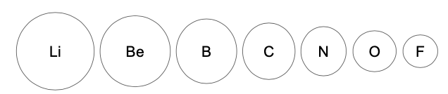

This result can be best explained on the basis of

1. Number of electron shell levels
2. Number of valence electrons
3. Effective nuclear charge
4. Arrangement in the Modern Periodic Table

Answer: c;

Level: Easy;

Taxonomy: Understand;

Topic: Periodic Classification of Elements

Score:1;

7. An element with atomic number 27 belongs to

1. Group 17, Period 4
2. Group 7, Period 3
3. Group 9, Period 4
4. Group 16, Period 3

Answer: c;

Level: Medium;

Taxonomy: Apply;

Topic: Periodic Classification of Elements

Score:1;

8. Three elements P,Q,R form the members of the Dobereiner’s Triad. It is found that the sum of the atomic weights of the first and last elements of the triad is 300 and the ratio of the atomic masses of the first two elements is 6:25. The atomic weights of P, Q and R respectively are

1. 36, 150, 264
2. 30, 150, 270
3. 50, 125, 250
4. 32, 125, 268

Answer:a ;

Level: Hard;

Taxonomy: Apply;

Topic: Periodic Classification of Elements

Score:1;

9.Four elements A, B,C and D have their electronic configurations as shown.

A (2,7) B (2,8,8) C (2,8,6) D(2,8,8,2).

Identify the element(s) that could form a covalent bond with an element with electronic configuration 2,4.

1. A, B
2. B, C
3. A, C
4. A, C, D

Answer: c;

Level: Medium;

Taxonomy: Apply;

Topic: Periodic Classification of Elements

Score:1;

10. Study the following table

|  |  |  |
| --- | --- | --- |
| Set | Name | Atomic Mass (u) |
| 1 | A  B  C | 40  89  140 |
| 2 | X Y  Z | 7  23  39 |
| 3 | P  Q  R | 35.5  87  129 |

Which among these sets is a Dobereiner’s Triad?

1. 1 only
2. 2 & 3 only
3. 2 only
4. All of them

Answer: c;

Level: Medium;

Taxonomy: Analyze;

Topic: Periodic Classification of Elements

Score:1;

11. In the Modern Periodic Table, X is placed in the 2nd period and 15th group while Y is located in the 3rd period and 15th group. The difference between the atomic numbers of X and Y is

1. 7
2. 8
3. 15
4. 14

Answer:b ;

Level: Easy;

Taxonomy: Analyze;

Topic: Periodic Classification of Elements

Score:1;

12. An element has atomic number Z = 30. It belongs to

1. s block
2. p block
3. d block
4. f block

Answer: c;

Level: Medium

Taxonomy: Analyze;

Topic: Periodic Classification of Elements

Score:1;

13. The atomic radius (in pm) of Ne, Kr and Xe are 38, 88 and 108 respectively. Using this information, a reasonable estimate of the atomic radius of Ar could be

1. 31 pm
2. 71 pm
3. 91 pm
4. 111 pm

Answer: b;

Level: Medium;

Taxonomy: Analyze;

Topic: Periodic Classification of Elements

Score:1;

14. Assess the following properties given below.

1. High electrical conductivity
2. Low density
3. Reacts with cold water

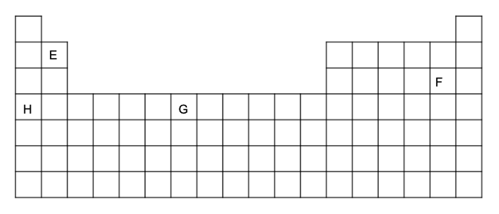

The element being described might be

1. E
2. F
3. G
4. H

Answer:d ;

Level: Medium;

Taxonomy: Evaluate;

Topic: Periodic Classification of Elements

Score:1;

15. The trends shown by period 3 in the periodic table are shown here. 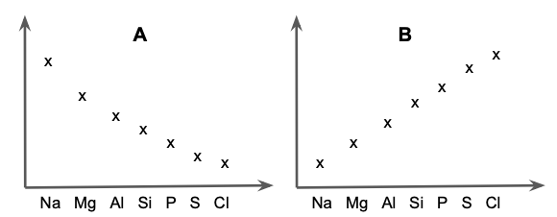

These graphs indicate trends in

|  |  |  |
| --- | --- | --- |
|  | **A** | **B** |
| a. | Atomic Radius | No. of protons |
| b. | Melting Point | Valency |
| c. | Ionic Radius | Electronegativity |
| d. | Boiling point | Atomic Number |

Answer: a;

Level: Medium;

Taxonomy: Evaluate;

Topic: Periodic Classification of Elements

Score:1;

16. Select the true statement about elements in Group 1 and Group 17 of the Modern Periodic Table.

1. Sodium reacts with water more vigorously than potassium does.
2. Bromine is a monatomic nonmetal.
3. Rubidium is denser than Lithium.
4. Hydrogen fluoride is a stronger acid than all other hydrogen halides.

Answer: c;

Level: Medium;

Taxonomy: Evaluate;

Topic: Periodic Classification of Elements

Score:1;

17. The correct order of increasing metallic character is

1. Cu < Al < Na < Ca < Sr < Cs
2. Al < Na < Ca < Sr < Cs < Cu
3. Na < Al < Ca < Cu < Sr < Cs
4. Cs > Sr > Cu > Al > Na > Ca

Answer: a;

Level: Hard;

Taxonomy: Evaluate;

Topic: Periodic Classification of Elements

Score:1;

18. Iodine can be used as a disinfectant due to its broad spectrum of antimicrobial activity.

Options

1. True
2. False

Answer:True ;

Level: easy;

Taxonomy: Remember;

Topic: Periodic Classification of Elements

Score:1;

19. When a solution of bromine is added to a colourless solution of potassium chloride, the solution turns orange.

Options

1. True
2. False

Answer: False;

Level: Hard;

Taxonomy: Remember;

Topic: Periodic Classification of Elements

Score:1;

20. Sodium ions are smaller in size in comparison to sodium atoms.

Options

1. True
2. False

Answer: True;

Level: Medium;

Taxonomy: Understand;

Topic: Periodic Classification of Elements

Score:1;

21. Mendeleev predicted the existence of Gallium and named it ___________ when he left spaces for it in his periodic table.

Answer: Eka-aluminium;

Level: easy;

Taxonomy: Remember;

Topic: Periodic Classification of Elements

Score:1;

22. In the Modern Periodic Table, a zig-zag line separates metals from non-metals. ________ is the smallest borderline element showing intermediate properties of metals and non-metals.

Answer: Boron;

Level: Medium;

Taxonomy: Remember;

Score:1;

23. Non-metals tend to form bonds by gaining electrons. This is because they are __________ in nature.

Answer: Electronegative;

Level: easy;

Taxonomy: Understand;

Topic: Periodic Classification of Elements

Score:1;

24. The noble gases are unreactive, and form _______ molecules, because their atoms already have a stable outer electron shell.

Answer: Monoatomic;

Level: hard;

Taxonomy: Understand;

Topic: Periodic Classification of Elements

Score:1;

25. Match the following.

Each letter may be used once, more than once or not at all.

|  |  |
| --- | --- |
| 1. Belongs to group 13 2. Noble gas 3. Forms a doubly negative charged ion 4. Most electronegative 5. Similar properties to Ga |  |

Answer:

1. B
2. E
3. A
4. C
5. B;

Level: Medium;

Taxonomy: Remember;

Topic: Periodic Classification of Elements

Score:5;

26. State the law which governs the basis of formation of Moseley’s classification of elements.

Answer: Modern Periodic Law- Properties of elements are periodic functions of their atomic masses.;

Level: easy;

Taxonomy: Understand;

Topic: Periodic Classification of Elements

Score:1;

27. What is the basis of Dobereiner’s attempt to classify elements?

Answer: He identified some groups having three elements each called triads and showed that when the three elements in a triad were written in the order of increasing atomic masses; the atomic mass of the middle element was roughly the average of the atomic masses of the other two elements.;

Level: easy;

Taxonomy: Understand;

Topic: Periodic Classification of Elements

Score:1;

28. Illustrate the term atomic radius by using a diagram.

Answer: 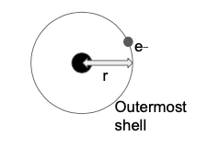 or 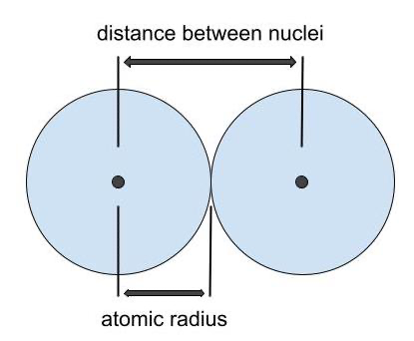;

Level: Medium;

Taxonomy: Apply;

Topic: Periodic Classification of Elements

Score:1;

29. An element X has the atomic number 20. Deduce the formula of its sulphate.

Answer: X : 2,8,8,2

Valency : +2

Formula: XSO4;

Level: Medium;

Taxonomy: Apply;

Topic: Periodic Classification of Elements

Score:1;

30. Explain why a molecule of Fluorine is made up of 2 fluorine atoms while that of Neon contains only 1 atom of Neon.

Answer: While Ne has a completely filled outer electron shell, each fluorine atom has only seven valence electrons. To achieve octet configuration, the two fluorine atoms must combine to share one electron amongst them.;

Level: easy;

Taxonomy: Apply;

Topic: Periodic Classification of Elements

Score:1;

31. Explain the rules of arrangement of electrons in the elements belonging to the first three periods of the modern periodic table. Cite relevant examples.

Answer:

The electrons are arranged in different shells each at different energy levels starting at the lowest. The maximum number of electrons that can be accommodated in a shell depends on the formula 2n2 where ‘n’ is the number of the given shell from the nucleus.

For the first period, we have the first shell with n=1, K shell with maximum capacity 2(1)2 = 2.

Thus H with just 1 electron has electronic configuration as 1 and He would thereby have the configuration as having 2 electrons in the K shell.

Period 2 has the energy level, n=2 with a total capacity of 8 electrons i.e., a filled K shell and occupied L shell. Thus Li to Ne would follow subsequent configuration from 2,1(Li), 2,2 (Be)... to 2,8 (Ne).

The next period would move on to the next higher energy shell M (n=3) with K, L and M shells filling the last orbitals in M shell filling into its stable octet configuration.

Thus Na to Ar would follow subsequent configuration from 2,8,1(Na), 2,8,2 (Mg)... to 2,8,8 (Ar).

Level: Medium;

Taxonomy: Understand;

Topic: Periodic Classification of Elements

Score:3;

32. Use a simple diagram to describe the bonding between an element X with atomic number 20 and an element Y with atomic number 8.

*Answer:*

X = Ca : 2,8,8,2

Y = O : 2,6

They make an ionic bond.

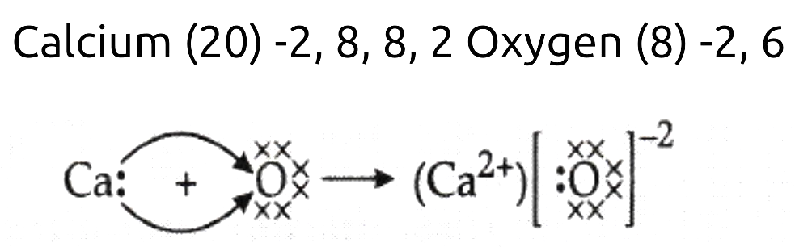

Level: easy;

Taxonomy: Understand;

Topic: Periodic Classification of Elements

Score:3;

33. Arrange the following in the increasing order of their basic character. Give reasons for your answer.

CuO, Al2O3, Cs2O, CaO, Na2O, SrO

*Answer:*

Alkali metal oxides are most basic followed by alkaline earth metal oxides while transition metal oxides are least basic. Amongst alkali and alkaline earth metal oxides, basicity increases down the group.

CuO< Al2O3 < Na2O < CaO < SrO < Cs2O

Level: Hard;

Taxonomy: Apply;

Topic: Periodic Classification of Elements

Score:3;

34. Consider the following information.

|  |  |  |  |  |
| --- | --- | --- | --- | --- |
| Element | Proton no. | Mass no. | EC | Melting Point (K) |
| Be | 4 | 9 | 1s22s2 | 1560 |
| Mg | 12 | 24 | [Ne]3s2 | 923 |
| Ca | 20 | 40 | [Ar]4s2 | 1115 |
| Sr | ? | 87 | ? | ? |

Based on the information and your knowledge of Be, Mg and Ca,

1. Predict the missing data for Sr to the best of your ability.
2. Describe the trends in melting points as you go down the group if the melting point of Ba is 1000K.
3. Deduce the formula of Strontium phosphate.
4. What would you observe on adding Barium to water containing a drop of phenolphthalein? Write the equation for the reaction and name the products involved.

Answer:

a) Sr   
Z= 38, EC : [Kr]4s2, melting point < 1115K

b) There is a general decrease in melting point going down group 2 with the exception of Mg. If we include magnesium, there is no obvious trend in melting points.

c) Sr3(PO4)2

d) Ba would react with water to produce an alkali barium hydroxide, Ba(OH)2 and hydrogen gas which would turn the solution pink.

Ba + H2O→ Ba(OH)2 + H2

Level: Medium;

Taxonomy: Apply;

Topic: Periodic Classification of Elements

Score:3;

35. Both Mg and S form chlorides with the formula XCl2 despite being members of different groups in the periodic table. Explain the reason.

*Answer:*

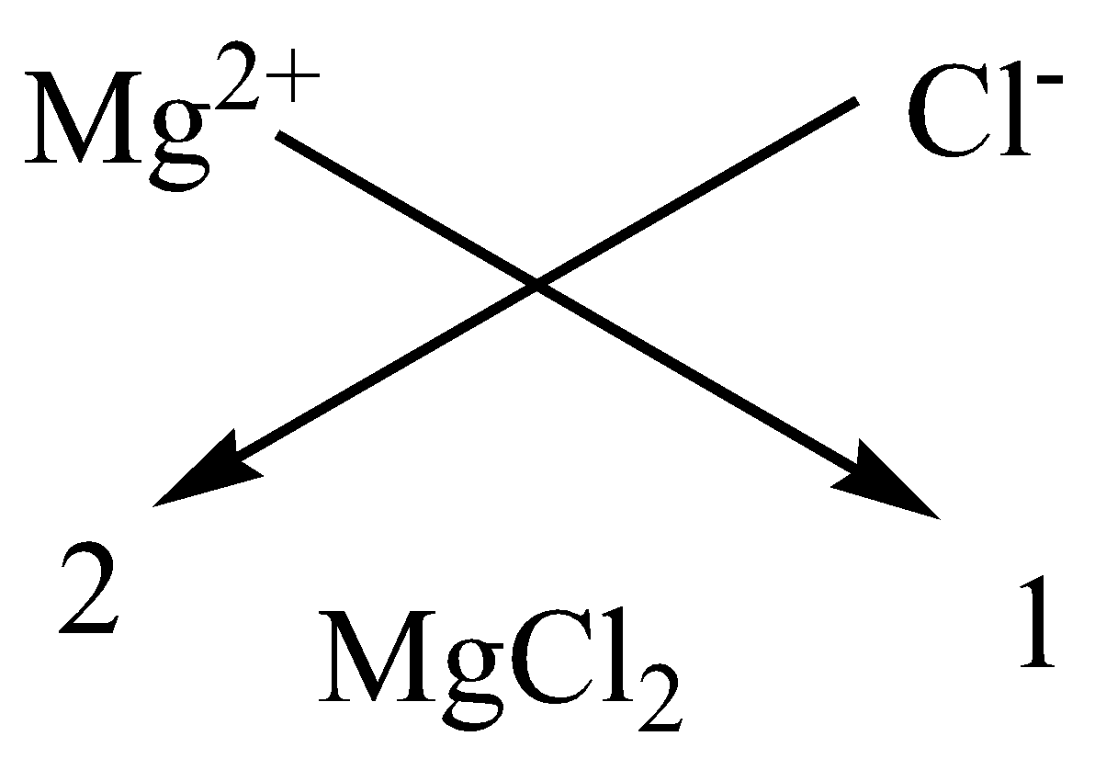

Because both elements have a valency of 2.

Mg : 2,8,2 has two electrons in the outermost shell. In order to achieve the nearest noble gas configuration, it is easier to lose the 2 valence electrons to form Mg2+. While combining with Cl with a valency of 1, it forms MgCl2.

On the other hand, S : 2,8,6 needs 2 electrons to achieve the nearest octet configuration. It’s easier to gain 2 electrons than to lose 6, and thus would achieve valency 2. Like Mg, when S combines with Cl, it forms SCl2.

Answer: ;

Level: easy;

Taxonomy: Apply;

Topic: Periodic Classification of Elements

Score:3;

36. What ideas validate the Mendeleev’s Periodic Table?

*Answer :*

1. Basis of Classification - increasing order of atomic mass and reaction of elements with H and O.
2. Vacant spaces for future discoveries
3. Ability to predict the properties of the elements to aid the discovery of element

Placement of inert gases after their discovery without disturbing the existing table.

Level: easy;

Taxonomy: Analyze;

Topic: Periodic Classification of Elements

Score:3;

37. Explain the trend shown here.

|  |  |  |  |  |
| --- | --- | --- | --- | --- |
| Element | Be | Mg | Ca | Sr |
| Atomic Radius (ppm) | 89 | 136 | 174 | 191 |

*Answer :*

1. Down a group, the number of energy levels (n) increases, so there is a greater distance between the nucleus and the outermost orbital.  
2. The effective nuclear charge on the valence electrons decreases down the group as the outermost electrons are farther away from the nucleus.

These result in a larger atomic radius as you move down the group.

Level: Medium;

Taxonomy: Analyze;

Topic: Periodic Classification of Elements

Score:3;

38. The properties of four different elements are shown here.

|  |  |  |  |  |
| --- | --- | --- | --- | --- |
| Substance | Boiling Point | Density in  g/cc | Electrical conductivity of solid | Electrical conductivity when molten |
| Graphite | low | 2.23 |  | Conducts |
| KI | high | 3.12 | Conducts | Conducts |
| C20H42 | low | 0.8 |  | Doesn’t conduct |
| Al | high | 2.70 | Conducts | Conducts |

1. Aluminium is a preferred metal choice for building aircrafts. Select one piece of evidence from the table to support the claim.
2. Complete the electrical conductivity of graphite and C20H42 in their solid state. Justify your answer.
3. Illustrate the type of bonding in KI using Lewis structures with reference to the properties here.

*Answer:*

a) Low density

b) Graphite - Conducts (free electrons)

C20H42 - doesn’t conduct

(No free electrons due to maximum covalent bonds)

c) 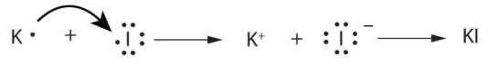

Level: Medium;

Taxonomy: Analyze;

Topic: Periodic Classification of Elements

Score:3;

39. The position of Hydrogen in the Periodic Table is ambiguous. Justify.

*Answer:*  
Electronic configuration of hydrogen resembles that of alkali metals. Like alkali metals, hydrogen combines with halogens, oxygen and sulphur to form compounds having similar formulae.  
On the other hand, just like halogens, hydrogen also exists as diatomic molecules and it combines with metals and non-metals to form covalent compounds. Hence, no fixed position can be given to hydrogen in the Periodic Table.

Level: Medium

Taxonomy: Evaluate;

Topic: Periodic Classification of Elements

Score:3;

40. The modern element-hunting era began in the nineteen-thirties, when the physicist Ernest Lawrence directed scientists at the University of California, Berkeley, to develop a series of devices, called cyclotrons, that use electricity to blast protons into foil targets installed inside metal chambers. Researchers soon found that some of the supercharged nuclear particles would glom onto the atoms in the targets and create bigger, heavier elements,, and by 1937 one of his devices had created technetium (element No. 43), an atom predicted by Mendeleev. Like all elements first born in cyclotrons, technetium was radioactive. Lawrence won a Nobel Prize for his invention in 1939; that same year, Einstein told President Roosevelt to get working on a nuclear weapon.

a) Where would Lawrence have needed to place Technetium on the modern Periodic table? Elaborate.

b) If TcS2 is converted to Tc2S7, would the change be considered a redox reaction?

*Answer:*

a) Placement would be in the 7th group and 5th period.

The EC of Tc : 2,8,8,18,7

No. of shells is the period = 5

No. of valence electrons is the group no. = 7

b) The change is oxidation. Since S isn’t undergoing reduction in this change, it is not a redox reaction.

Level: Hard;

Taxonomy: Evaluate;

Topic: Periodic Classification of Elements

Score:3;

41. Given below is a graph depicting the electro-negativity in the elements from 1 to 20.

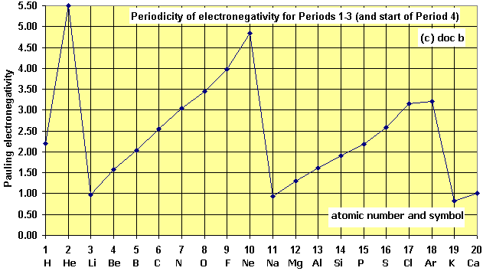

1. What is meant by the term electronegativity?
2. Explain the periodicity in trends depicted here.
3. This trend decreases down the group. Give reasons.

*Answer:*

1. The ability or power of an atom to attract electron charge towards it, in the context of a pair of electrons of a covalent bond linking it to another different atom.
2. Electronegativity generally increases from left to right across a period, as the actual and effective nuclear charge increases within the same energy level pulling the electrons closer to the nucleus.
3. Electronegativity decreases as we move down the group because as we move down the group, the atomic size increases and the effective nuclear charge decreases. Therefore, the tendency to attract shared pairs of electrons decreases, thereby decreasing electronegativity.

Level: Medium;

Taxonomy: Evaluate;

Topic: Periodic Classification of Elements

Score:3;

42. Germanium is a metalloid placed in group 14 of the modern periodic table, which has important applications as a semiconductor.

Germanium forms a similar series of saturated hydrides like alkanes.

1. Construct the structural formula of a hydride which has two Ge atoms per molecule.
2. Illustrate the nature of bonding in the above molecule by drawing its electron dot structure.
3. In this reaction GeCl4 is converted to GeCl.
4. 2GeCl4 + 3H2→ 2GeCl + 6HCl
5. Is the change due to oxidation, reduction or neither? Explain.

Answer:

a. 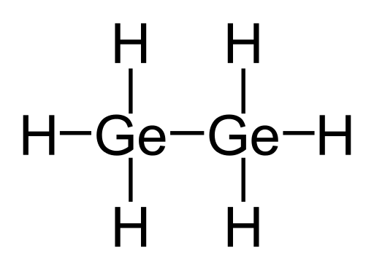

b. 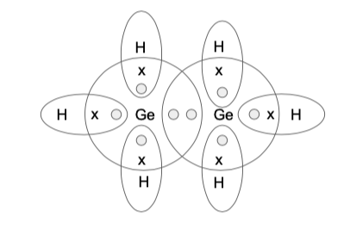

c. The change is oxidation since it’s the removal of the electronegative Cl element*.*

Level: Hard;

Taxonomy: Analyze;

Topic: Periodic Classification of Elements

Score:5;

43. lement Z is a non-metal and is the lightest element in Group 15. It reacts with oxygen to form a very interesting and important family of air polluting chemical compounds often denoted as ZOx. ZO is kinetically stable and doesn’t react with water, acids and bases. But in the presence of air, it forms acid HOZO.

4ZO + O2 + 2H2O→ 4HZO2

However the acid is highly unstable.

2HZO2 → ZO2 + ZO + H2O (cold dilute soln)

3HZO2 → HZO3 + 2ZO + H2O (hot conc soln)

1. Draw the electron dot structure of the Z molecule.
2. What is the nature of ZO? What colour would the solution of the same show when a drop of universal indicator is added?
3. Consider the reaction of the acid HZO2 in cold dilute solution. What type of reaction is happening here?
4. Is this reaction a redox reaction?

3HZO2 → HZO3 + 2ZO + H2O

If yes, identify the oxidation and reduction half reactions.

Answer:

a. 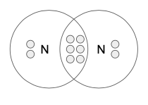

b. Neutral. Green

c. Decomposition reaction or disproportionation reaction

d. Yes, it’s a redox reaction.

Ox: HZO2 → HZO3

Red: HZO2 → ZO

Level: Medium;

Taxonomy: Analyze;

Topic: Periodic Classification of Elements

Score:5;

44. A,B,C and D are the members of the 3rd period in the modern periodic table arranged in a consecutive fashion.

**A** is non-toxic, has high resistance to corrosion and can be cast, machined and moulded quickly. It’s a silvery white metal.

**D** is a solid which exists as several isotopes. **D** burns in air to form DO2, which turns blue litmus red in solution form. The solution forms neutral salt Na2DO3 on reaction with NaOH.

Suggest the identities of A,B, C and D.

Devise the most probable formula of the oxide of C.

The oxide of A is amphoteric in nature. Write equations for its reaction with NaOH.

Suggest the type of bonding most prevalent in reactions of element B. Give reason for the same.

Answer:

1. Al, Si, P and S respectively.
2. C3O2
3. Al2O3 + NaOH → NaAlO2 + H2O
4. Covalent bonding. Silicon (Si) is tetravalent in nature just like Carbon (C) . That means it can share all four of its valence electrons to form covalent bonds with other atoms or molecules much easier than losing or gaining 4 electrons to complete its octet configuration. So in order to be stable, Silicon(Si)needs to form four covalent bonds

Level: Hard;

Taxonomy: Evaluate;

Topic: Periodic Classification of Elements

Score:5;

45. Consider the following elements

|  |
| --- |
| A(19), B(6), C(13), D(14), E(38), F(31) |

a. Devise a way to categorise the following elements on the basis of formation of oxides.

Explain your reasoning for the same.

b. Elements A and E can’t combine to form a salt. Justify.

Answer:

a)

|  |  |  |
| --- | --- | --- |
| Element | EC | Formula of oxide |
| A | 2,8,8,1 | A2O |
| B | 2,4 | BO2 |
| C | 2,8,3 | C2O3 |
| D | 2,8,4 | DO2 |
| E | 2,8,8,18,2 | EO |
| F | 2,8,8,13 | F2O3 |

On the basis of the similarity in the formation of oxides -

C and F can be in the same group

B and D are members of the same group

b) Both A and E are metals and they both have the tendency to lose electrons and thus can’t undergo a combination reaction. The transfer of electrons is not possible.

Level: Medium;

Taxonomy: Create;

Topic: Periodic Classification of Elements

Score:5;

46. An ion is formed when an element loses or gains outermost electrons in order to attain noble gas configuration. Organise the following in the increasing order of their atomic sizes. Justify your answer.

|  |
| --- |
| F, O2-, Li+, B3+, N3- |

*Answer:*

|  |  |  |  |  |  |
| --- | --- | --- | --- | --- | --- |
|  | F | O2- | Li+ | B3+ | N3- |
| EC of atom | 2,7 | 2,6 | 2,1 | 2,3 | 2,5 |
| EC of ion | - | 2,8 | 2 | 2 | 2,8 |
| Size comparison | -  - | O2->O | Li+ < Li | B3+< B | N3- > N |

Atomic radius decreases across the period.

Li > B > N > O > F

B3+ < Li+ since B has greater nuclear charge in comparison to the number of electrons than Li which pulls the valence shell closer to the nucleus. Thus it's smaller.

Similarly, N3- has greater no. of electrons added in the outer shell than O2-. Electrons would repel each other and N3- would be larger in size than O2-. Both these ions would be larger in size than neutral F.

The increasing order of atomic radius is

B3+ < Li+< F < O2- < N3-

Level: Hard;

Taxonomy: Create;

Topic: Periodic Classification of Elements

Score:5;

47. Reactivity across the third period elements is roughly depicted as follows.

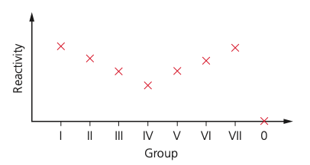

How would you explain this trend?

Answer:

Reactivity *decreases* across the metals. Aluminium is a lot less reactive than sodium.This is because the more electrons a metal atom needs to lose, the more difficult it is. (The electrons must have enough energy to overcome the pull of the nucleus.)

The reactivity increasesacross the non-metals (apart from Group 0). So chlorine is more reactive than sulphur, because the fewer electrons a non-metal atom needs to gain, the easier it is to attract them.

Level: Medium

Taxonomy: Understand;

Topic: Periodic Classification of Elements

Score:3;

48. Complete the electron-dot structure to indicate bonding in an O2 molecule. What can you say about the nature of bonding in this molecule?

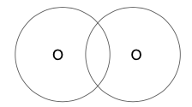

Answer:

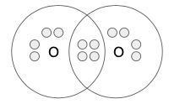

N atoms undergo a triple covalent bond to form a N2 molecule.

Level: easy;

Taxonomy: Understand;

Topic: Periodic Classification of Elements

Score:3;

49. Consider the following, and select the element which best matches the descriptions below

.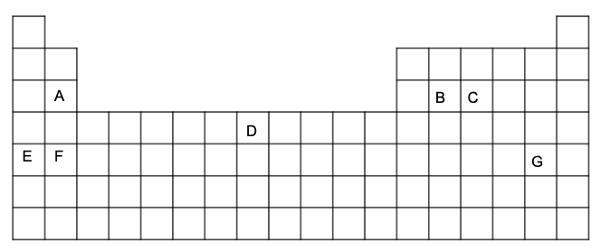

1. An element which reacts with hot water.
2. Element with the lowest density.
3. An element whose oxides can be in the form of either XO or X2O3.
4. An element which exists as a polyatomic molecule.
5. An element which displays catenation.
6. The element with the largest atomic size.

Answers:

1. A
2. E
3. D
4. C
5. B
6. G

Level: Medium;

Taxonomy: Create;

Topic: Periodic Classification of Elements

Score:3;

50.Observe the periodic table depicted below.

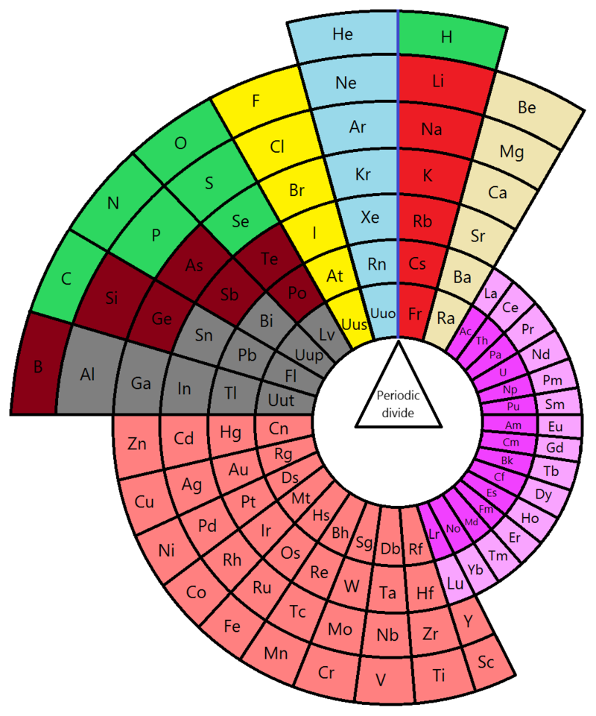

a) How would you explain the basis of classification of elements in this periodic table? How is this table different from the standard modern periodic table?

b) What facts can you gather from this periodic table?

c) Why are these tables called “periodic tables”?

Answer:

a) Basis of classification - spdf blocks

Differences:

b) i) Different subcategories of elements - alkali metals, alkaline earth metals, noble gases, nonmetals and halogens, metalloids, Lanthanides and Actinides etc

ii) Circular arrangement inside of rows and columns

iii) No. of elements in each group.

iv) Identify elements similar in their properties.

c) This is because the periodic table organises all known elements according to their properties so that elements with similar properties are grouped together in the same vertical column. The rows are also called periods.

Level: Hard;

Taxonomy: Create;

Topic: Periodic Classification of Elements

Score:5;

**ENGLISH – Ch- Letter to God**

1. Lencho’s house overlooked____

1. a river and corn fields.
2. a small house
3. a low hill
4. the post office

Answer: a;

Level: easy;

Taxonomy: Remember;

Topic: Letter to God

Score:1;

2. What direction did the rain clouds come from?

1. north-east
2. north west
3. north
4. east

Answer:a ;

Level: easy;

Taxonomy: Remember;

Topic: Letter to God

Score:1;

3. How long did the hailstones fall?

1. an hour
2. half an hour.
3. less than an hour
4. d. almost an hour

Answer: a;

Level: easy;

Taxonomy: Remember;

Topic: Letter to God

Score:1;

4.When did it rain?

1. During dinner
2. During lunch
3. During breakfast
4. During prayer time

Answer: a;

Level: easy;

Taxonomy: Understand;

Topic: Letter to God

Score:1;

5.What was considered as five cent coins?

small drops of rain

big drops of rain

small hailstones

d. big hailstones

Answer: a;

Level: easy;

Taxonomy: Understand;

Topic: Letter to God

Score:1;

6.What would have spared a few crops?

1. locusts
2. rain
3. salt
4. d. plague

Answer:a ;

Level: easy;

Taxonomy: Understand;

Topic: Letter to God

Score:1;

7. The phrase ‘frozen pearls’ is an example of _____ .

1. Simile
2. metaphor
3. alliteration
4. repetition

Answer:b ;

Level: easy;

Taxonomy: Apply;

Topic: Letter to God

Score:1;

8. Lencho knew his fields intimately. This line means___

1. he was an experienced farmer
2. his fields were close to his house
3. he loved corns
4. he was a hard working farmer.

Answer: a;

Level: easy;

Taxonomy: Apply;

Topic: Letter to God

Score:1;

9. Apart from the post office employees, who else contributed money for Lencho?

1. Lencho’s friends
2. Friends of the postmaster
3. Post office employees
4. both b and c

Answer: b;

Level: easy;

Taxonomy: Apply;

Topic: Letter to God

Score:1;

10. Hailstones looked like ____.

1. silver coins
2. frozen pearls
3. new coins
4. both a and b

Answer: d;

Level: easy;

Taxonomy: Analyze;

Topic: Letter to God

Score:1;

11. “That’s what they say: no one dies of hunger.” Who are they?

1. neighbours
2. friends
3. religious heads
4. post office employees

Answer: c;

Level: easy;

Taxonomy: Analyze;

Topic: Letter to God

Score:1;

12. Lencho was an ox of a man. This is an example of ___.

1. Personification
2. metaphor
3. alliteration
4. anaphora

Answer: b;

Level: easy;

Taxonomy: Analyze;

Topic: Letter to God

Score:1;

13.Who handed the reply letter to Lencho?

1. Postman
2. Postmaster
3. Post office employees
4. Both a and b

Answer: a;

Level: easy;

Taxonomy: Analyze

Topic: Letter to God

Score:1;

14. The initial reaction of the postmaster on seeing the letter was of ____.

1. laughter
2. surprise
3. curiosity
4. anxiety

Answer: a;

Level: easy;

Taxonomy: Evaluate;

Topic: Letter to God

Score:1;

15. The resolution of the postmaster was to____

1. render genuine monetary help
2. convey his best wishes
3. act as God
4. pray to God

Answer: a;

Level: easy;

Taxonomy: Evaluate;

Topic: Letter to God

Score:1;

16. The postmaster expressed ___ after putting the money in an envelope.

1. satisfaction
2. worry
3. anxiety
4. curiosity

Answer: a ;

Level: easy;

Taxonomy: Evaluate;

Topic: Letter to God

Score:1;

17. On receiving seventy pesos, Lencho was _____.

1. angry
2. sad
3. jealous
4. worried

Answer: a;

Level: easy;

Taxonomy: Evaluate;

Topic: Letter to God

Score:1;

18. The much anticipated rain clouds appeared while Lencho was having his afternoon meal.

Options

1. True
2. False

Answer: False;

Level: easy;

Taxonomy: Remember;

Topic: Letter to God

Score:1;

19. The locusts had also damaged the corn fields.

Options

1. True
2. False

Answer:False ;

Level: easy;

Taxonomy: Remember;

Score:1;

20. Lencho wrote the first letter to God at home.

Options

1. True
2. False

Answer: True;

Level: Medium;

Taxonomy: Understand;

Topic: Letter to God

Score:1;

21. The frozen pearls refer to _____

Answer: Hailstones;

Level: easy;

Taxonomy: Remember;

Topic: Letter to God

Score:1;

22. Lencho’s house was on the crest of a low hill. Here the word ‘crest’ means ____.

Answer: top;

Level: easy;

Taxonomy: Remember;

Score:1;

23. The main intention of the postmaster was to preserve Lencho’s ____.

Answer: Faith;

Level: easy;

Taxonomy: Understand;

Topic: Letter to God

Score:1;

24. According to Lencho, the corn fields would have been spared by ____ but not the hailstones.

Answer: A Plague of Locusts;

Level: Medium;

Topic: Letter to God

Taxonomy:Understand;

Score:1;

25. Match the following:

**Part A Part B**

1. The older boys 1. worked in the field.
2. Lencho 2. went out to enjoy the rain.
3. The raindrops 3. resembled new coins
4. Corn fields dotted with flowers 4. promised a good harvest
5. The younger boys 5. played near the house

Answer:

a-2

b-1

c-3

d-4

e-5;

Level: easy;

Taxonomy: Remember;

Topic: Letter to God

Score:5;

26. What can you infer from the old woman's words, "Yes, God willing "?

Answer: We can infer that the old woman was a believer in God.;

Level: Medium;

Taxonomy: Understand;

Topic: Letter to God

Score:1;

27. What is the main idea of the story, A Letter to God?

Answer: Man’s unwavering faith in the power of the almighty is the main idea of the story.;

Level: Medium;

Taxonomy: Understand;

Topic: Letter to God

Score:1;

28. Which example from the story conforms to the anger and frustration of Lencho?

Answer: Lencho was writing the second letter. After buying the stamp, he fixed it to the envelope with a blow of his fist. ;

Level: hard;

Taxonomy: Apply;

Topic: Letter to God

Score:1;

29. Why do you think the postmaster wanted to help Lencho, a complete stranger?

Answer: The postmaster, being an amiable person, was kind and genuine. He wanted to extend real help to the man who had great trust in God.;

Level: hard;

Taxonomy: Apply;

Topic: Letter to God

Score:2;

30. By calling the post office employees a bunch of crooks, Lencho displayed rude behaviour. Was he right? Give reasons.

Answer: Instead of appreciating the good gesture of the postmaster along with the post office employees, he mistook them as crooks. This was wrong as he had not verified his allegation. One must not draw conclusions or judge another person without having definite;

Level: Medium;

Taxonomy: Apply;

Topic: Letter to God

Score:2;

31. How were the raindrops described by Lencho?  
Answer: Lencho compared the raindrops with new coins. The big drops were regarded as ten cents and the smaller drops as five cents.

Level: medium;

Taxonomy: Understand;

Topic: Letter to God

Score:2;

32. Describe the impact of the hailstones on the valley.

Answer: The hail rained on the house, the garden, the hillside, the cornfield and the entire valley. The corn field was white like salt. Not a leaf remained on the trees. The corn was totally destroyed. The flowers were gone from the plants

Level: Medium;

Taxonomy: Understand;

Topic: Letter to God

Score:2;

33.Illustrate how the values of the postmaster are presented in the story?

Answer: The postmaster did not want to shake Lencho's faith. He realised that Lencho required financial help apart from good wishes. He decided to help Lencho with some money. He also sought money from his employees and friends to be given to Lencho.

Level: hard;

Taxonomy: Apply;

Topic: Letter to God

Score:2;

34. How else could Lencho have reacted when he did not receive the entire amount?

Answer: He could have been happy, contended and utilized the amount to buy the seeds.

Level: Medium;

Taxonomy: Apply;

Topic: Letter to God

Score:1;

35. Predict the postman’s emotions after reading Lencho’s second letter.

Answer. The postman definitely would feel upset after reading the contents of the second letter. He would have been expecting a note of gratitude.

However, later he would understand that Lencho’s unpleasant letter was due to his immense faith in God.

Level: Hard;

Taxonomy: Apply;

Topic: Letter to God

Score:3;

36. Lencho approached God and not anyone else. Elucidate.

Answer: Lencho was a poor farmer. With no one around to help him, he remembered that God was omnipresent. His innocent faith in the power of the Almighty prompted him to seek help from God.

Level: Medium;

Taxonomy: Analyze;

Topic: Letter to God

Score:2;

37. How do you explain the rude behaviour of Lencho for not receiving the desired amount of money?

Answer: Lencho’s unquestioning belief in God did not allow him to understand the situation. His firm conviction blinded him from looking into the improbability of the matter.

Level: Hard;

Taxonomy: Analyze;

Topic: Letter to God

Score:2;

38. What explanation do you have for Lencho calling them a bunch of crooks?

Answer: Lencho was sure that the people in the post office had stolen the remaining amount. He was confident that God would listen to his appeal and fulfil his wishes by sending him a hundred pesos. His confidence came from his strong faith.

Level: Hard;

Taxonomy: Analyze;

Topic: Letter to God

Score:3;

39.What is your opinion about the entire staff of the post office?

Answer: The postman, the postmaster and the employees contributed to the welfare of Lencho. At the post master’s request, every member agreed to contribute to help Lencho from distress. The employees were kind and benevolent.

Level: Medium;

Taxonomy: Evaluate;

Topic: Letter to God

Score:2;

40. Critique the behaviour of Lencho after opening the letter from God.

Answer: Lencho was eager to open the letter. His indomitable faith forced him to doubt the integrity of the post office employees.He did not hesitate to call them a bunch of crooks.

Level: Medium;

Taxonomy: Evaluate;

Topic: Letter to God

Score:2;

41. Justify the curiosity of the postmaster to see the reaction of Lencho?

Answer: The postmaster wanted to see the unwavering faith with which Lencho would believe that the money was indeed sent to him by God.

Level: Medium;

Taxonomy: Evaluate;

Topic: Letter to God

Score:2;

42.Worry ends where faith in God begins. How is this quote connected to Lencho’s life?

Answer: Total surrender to the power of the Almighty pacifies the anxious mind. Confidence in believing that the difficult times will pass gives hope to troubled minds.  
Lencho had a strong belief that only God would help him sail through the difficult times. With this strong conviction, he wrote a letter to God asking him to send him some money.

Level: hard;

Taxonomy: Analyze;

Topic: Letter to God

Score:6;

43. Analyse the character traits of both Lencho and the postman.

Answer: Lencho was a staunch believer of God. In his time of distress he sought help from God. However, When he did not receive the entire amount he did not hesitate to call the post office employees a bunch of crooks in this second letter to God.  
The postman on the other hand was a kind and generous man. He did not want Lencho to be disillusioned and hence along with his employees helped him with seventy pesos. He did not divulge his identity which reveals that he wanted Lencho’s faith to be intact.

Level: Medium;

Taxonomy: Analyze;

Topic: Letter to God

Score:6;

44. If you were the postman, how would you react to Lencho’s ungrateful attitude?

Answer: My initial reaction would be of shock and anger. Later I would forgive rude behaviour and ingratitude expressed due to his unwavering faith in God.

Level: hard;

Taxonomy: Evaluate;

Topic: Letter to God

Score:3;

45. Develop a proposal that would be successful in convincing Lencho about his misunderstanding and his subsequent irrational behaviour.

Answer: On seeing his frustration and anger, the postman, along with his employees, could have spoken with Lencho and made him understand that it was not God, but they had helped him. The post master could have written a separate letter to Lencho.

Level: Hard;

Taxonomy: Create;

Topic: Letter to God

Score:3;

46. Which image suits the way Lencho affixed the stamp for the second time?

  

a b c

Answer: a;

Level: easy;

Taxonomy: Understand;

Topic: Letter to God

Score:1;

47. Which image best describes Lencho’s house?

 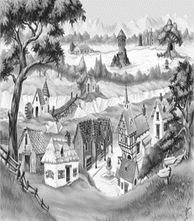 

a b c

Answer: a;

Level: easy;

Taxonomy: Understand;

Topic: Letter to God

Score:1;